Operations Management, 10e, Global Edition (Heizer/Render)
Module B Linear Programming

1) Linear programming helps operations managers make decisions necessary to make effective use of resources such as machinery, labor, money, time, and raw materials.
Answer: TRUE
Diff: 1
Topic: Why use linear programming?
Objective: no LO

2) One requirement of a linear programming problem is that the objective function must be expressed as a linear equation.
Answer: TRUE
Diff: 1
Topic: Why use linear programming?
Objective: no LO

3) A common form of the product-mix linear programming seeks to find that combination of products and the quantity of each that maximizes profit in the presence of limited resources.
Answer: TRUE
Diff: 2
Topic: Formulating linear programming problems
Objective: LO-Module B-1

4) Linear programming is an appropriate problem-solving technique for decisions that have no alternative courses of action.
Answer: FALSE
Diff: 1
Topic: Requirements of a linear programming problem
Objective: no LO

5) In linear programming, a statement such as "maximize contribution" becomes an objective function when the problem is formulated.
Answer: TRUE
Diff: 2
Topic: Formulating linear programming problems
Objective: LO-Module B-2

6) Constraints are needed to solve linear programming problems by hand, but not by computer.
Answer: FALSE
Diff: 1
Topic: Graphical solution to a linear programming problem
AACSB: Use of IT
Objective: LO-Module B-2

7) In terms of linear programming, the fact that the solution is infeasible implies that the "profit" can increase without limit.
Answer: FALSE
Diff: 2
Topic: Graphical solution to a linear programming problem
Objective: LO-Module B-2
8) The region that satisfies all of the constraints in graphical linear programming is called the region of optimality.
Answer: FALSE
Diff: 2
Topic: Graphical solution to a linear programming problem
Objective: LO-Module B-2

9) Solving a linear programming problem with the iso-profit line solution method requires that we move the iso-profit line to each corner of the feasible region until the optimum is identified.
Answer: FALSE
Diff: 2
Topic: Graphical solution to a linear programming problem
Objective: LO-Module B-2

10) The optimal solution to a linear programming problem is within the feasible region.
Answer: TRUE
Diff: 2
Topic: Graphical solution to a linear programming problem
Objective: LO-Module B-2

11) For a linear programming problem with the constraints 2X + 4Y ≤ 100 and 1X + 8Y ≤ 100, two of its corner points are (0, 0) and (0, 25).
Answer: FALSE
Diff: 2
Topic: Graphical solution to a linear programming problem
AACSB: Analytic Skills
Objective: LO-Module B-3

12) In linear programming, if there are three constraints, each representing a resource that can be used up, the optimal solution must use up all of each of the three resources.
Answer: FALSE
Diff: 2
Topic: Graphical solution to a linear programming problem
Objective: LO-Module B-2

13) The region that satisfies the constraint 4X + 15Z ≥ 1000 includes the origin of the graph.
Answer: FALSE
Diff: 1
Topic: Graphical solution to a linear programming problem
AACSB: Analytic Skills
Objective: LO-Module B-2

14) The optimal solution of a linear programming problem that consists of two variables and six constraints will probably not satisfy all six constraints precisely.
Answer: TRUE
Diff: 3
Topic: Graphical solution to a linear programming problem
Objective: LO-Module B-2
15) Sensitivity analysis of linear programming solutions can use trial and error or the analytic postoptimality method.
Answer: TRUE
Diff: 1
Topic: Sensitivity analysis
Objective: LO-Module B-4

16) In sensitivity analysis, a zero shadow price (or dual value) for a resource ordinarily means that the resource has not been used up.
Answer: TRUE
Diff: 3
Topic: Sensitivity analysis
Objective: LO-Module B-4

17) The graphical method of solving linear programming can handle only maximizing problems.
Answer: FALSE
Diff: 2
Topic: Solving minimization problems
Objective: LO-Module B-5

18) In linear programming, statements such as "the blend must consist of at least 10% of ingredient A, at least 30% of ingredient B, and no more than 50% of ingredient C" can be made into valid constraints even though the percentages do not add up to 100 percent.
Answer: TRUE
Diff: 3
Topic: Linear programming applications
AACSB: Reflective Thinking
Objective: LO-Module B-6

19) In which of the following has LP been applied successfully?
A) minimizing distance traveled by school buses carrying children
B) minimizing 911 response time for police patrols
C) minimizing labor costs for bank tellers while maintaining service levels
D) determining the distribution system for multiple warehouses to multiple destinations
E) all of the above
Answer: E
Diff: 1
Topic: Why use linear programming?
Objective: no LO

20) Which of the following represents valid constraints in linear programming?
A) 2X ≥ 7X*Y
B) 2X * 7Y ≥ 500
C) 2X + 7Y ≥100
D) 2X2 + 7Y ≥ 50
E) All of the above are valid linear programming constraints.
Answer: C
Diff: 2
Topic: Requirements of a linear programming problem
Objective: no LO
21) Which of the following is not a requirement of a linear programming problem?
A) an objective function, expressed in terms of linear equations
B) constraint equations, expressed as linear equations
C) an objective function, to be maximized or minimized
D) alternative courses of action
E) for each decision variable, there must be one constraint or resource limit
Answer: E
Diff: 2
Topic: Requirements of a linear programming problem
Objective: no LO

22) In linear programming, a statement such as "maximize contribution" becomes a(n)
A) constraint
B) slack variable
C) objective function
D) violation of linearity
E) decision variable
Answer: C
Diff: 2
Topic: Formulating linear programming problems
Objective: LO-Module B-1

23) If cars sell for $500 profit and trucks sell for $300 profit which of the following represents the objective function?
A) Maximize = 500C+300T
B) Minimize = 500C + 300T
C) Maximize = 500C — 300T
D) Minimize = 300T- 500C
E) None of the above
Answer: A
Diff: 2
Topic: Formulating linear programming problems
Objective: LO-Module B-1
24) The feasible region in the diagram below is consistent with which one of the following constraints?

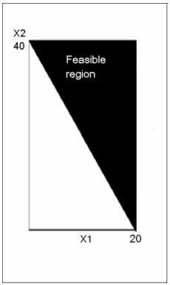
A) 8X1 + 4X2 ≤ 160
B) 8X1 + 4X2 ≥ 160
C) 4X1 + 8X2 ≤ 160
D) 8X1 - 4X2 ≤ 160
E) 4X1 - 8X2 ≤ 160
Answer: B
Diff: 3
Topic: Graphical solution to a linear programming problem
AACSB: Analytic Skills
Objective: LO-Module B-2
25) The feasible region in the diagram below is consistent with which one of the following constraints?

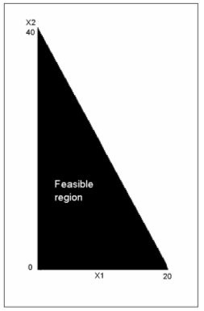
A) 8X1 + 4X2 ≥ 160
B) 4X1 + 8X2 ≤ 160
C) 8X1 - 4X2 ≤ 160
D) 8X1 + 4X2 ≤ 160
E) 4X1 - 8X2 ≤ 160
Answer: D
Diff: 2
Topic: Graphical solution to a linear programming problem
AACSB: Analytic Skills
Objective: LO-Module B-2

26) An iso-profit line
A) can be used to help solve a profit maximizing linear programming problem
B) is parallel to all other iso-profit lines in the same problem
C) is a line with the same profit at all points
D) none of the above
E) Fall of the above
Answer: E
Diff: 2
Topic: Graphical solution to a linear programming problem
Objective: LO-Module B-2
27) Which of the following combinations of constraints has no feasible region?
A) X + Y > 15 and X — Y < 10
B) X + Y > 5 and X > 10
C) X > 10 and Y > 20
D) X + Y > 100 and X + Y < 50
E) All of the above have a feasible region.
Answer: D
Diff: 2
Topic: Graphical solution to a linear programming problem
AACSB: Analytic Skills
Objective: LO-Module B-2

28) The corner-point solution method requires
A) finding the value of the objective function at the origin
B) moving the iso-profit line to the highest level that still touches some part of the feasible region
C) moving the iso-profit line to the lowest level that still touches some part of the feasible region
D) finding the coordinates at each corner of the feasible solution space
E) none of the above
Answer: D
Diff: 2
Topic: Graphical solution to a linear programming problem
Objective: LO-Module B-3

29) Which of the following sets of constraints results in an unbounded maximizing problem?
A) X + Y > 100 and X + Y < 50
B) X + Y > 15 and X — Y < 10
C) X + Y < 10 and X > 5
D) X < 10 and Y < 20
E) All of the above have a bounded maximum.
Answer: B
Diff: 2
Topic: Graphical solution to a linear programming problem
AACSB: Analytic Skills
Objective: LO-Module B-2

30) The region which satisfies all of the constraints in graphical linear programming is called the
A) area of optimal solutions
B) area of feasible solutions
C) profit maximization space
D) region of optimality
E) region of non-negativity
Answer: B
Diff: 2
Topic: Graphical solution to a linear programming problem
Objective: LO-Module B-2
31) Using the graphical solution method to solve a maximization problem requires that we
A) find the value of the objective function at the origin
B) move the iso-profit line to the highest level that still touches some part of the feasible region
C) move the iso-cost line to the lowest level that still touches some part of the feasible region
D) apply the method of simultaneous equations to solve for the intersections of constraints
E) none of the above
Answer: B
Diff: 2
Topic: Graphical solution to a linear programming problem
Objective: LO-Module B-2

32) For the two constraints given below, which point is in the feasible region of this maximization problem? (1) 14x + 6y < 42 (2) x - y < 3
A) x = 2, y = 1
B) x = 1, y = 5
C) x = -1, y = 1
D) x = 4, y = 4
E) x = 2, y = 8
Answer: A
Diff: 2
Topic: Graphical solution to a linear programming problem
AACSB: Analytic Skills
Objective: LO-Module B-3

33) For the two constraints given below, which point is in the feasible region of this minimization problem? (1) 14x + 6y > 42 (2) x - y > 3
A) x = -1, y = 1
B) x = 0, y = 4
C) x = 2, y = 1
D) x = 5, y = 1
E) x = 2, y = 0
Answer: D
Diff: 2
Topic: Graphical solution to a linear programming problem
AACSB: Analytic Skills
Objective: LO-Module B-3

34) What combination of x and y will yield the optimum for this problem?
Maximize $3x + $15y, subject to (1) 2x + 4y < 12 and (2) 5x + 2y < 10.
A) x = 2, y = 0
B) x = 0, y = 3
C) x = 0, y = 0
D) x = 1, y = 5
E) none of the above
Answer: B
Diff: 2
Topic: Graphical solution to a linear programming problem
AACSB: Analytic Skills
Objective: LO-Module B-3
35) What combination of x and y will yield the optimum for this problem?
Minimize $3x + $15y, subject to (1) 2x + 4y < 12 and (2) 5x + 2y < 10.
A) x = 2, y = 0
B) x = 0, y = 3
C) x = 0, y = 0
D) x = 1, y = 5
E) none of the above
Answer: C
Diff: 2
Topic: Graphical solution to a linear programming problem
AACSB: Analytic Skills
Objective: LO-Module B-3

36) What combination of a and b will yield the optimum for this problem?
Maximize $6a + $15b, subject to (1) 4a + 2b < 12 and (2) 5a + 2b < 20.
A) a = 0, b = 0
B) a = 3, b = 3
C) a = 0, b = 6
D) a = 6, b = 0
E) cannot solve without values for a and b
Answer: C
Diff: 2
Topic: Graphical solution to a linear programming problem
AACSB: Analytic Skills
Objective: LO-Module B-3

37) A maximizing linear programming problem has two constraints: 2X + 4Y < 100 and 3X + 10Y < 210, in addition to constraints stating that both X and Y must be nonnegative. The corner points of the feasible region of this problem are
A) (0, 0), (50, 0), (0, 21), and (20, 15)
B) (0, 0), (70, 0), (25, 0), and (15, 20)
C) (20, 15)
D) (0, 0), (0, 100), and (210, 0)
E) none of the above
Answer: A
Diff: 2
Topic: Graphical solution to a linear programming problem
AACSB: Analytic Skills
Objective: LO-Module B-3
38) A linear programming problem has two constraints 2X + 4Y ≤ 100 and 1X + 8Y ≤ 100. Which of the following statements about its feasible region is true?
A) There are four corner points including (50, 0) and (0, 12.5).
B) The two corner points are (0, 0) and (50, 12.5).
C) The graphical origin (0, 0) is not in the feasible region.
D) The feasible region includes all points that satisfy one constraint, the other, or both.
E) The feasible region cannot be determined without knowing whether the problem is to be minimized or maximized.
Answer: A
Diff: 2
Topic: Graphical solution to a linear programming problem
AACSB: Analytic Skills
Objective: LO-Module B-3

39) A linear programming problem has two constraints 2X + 4Y ≥ 100 and 1X + 8Y ≤ 100. Which of the following statements about its feasible region is true?
A) There are four corner points including (50, 0) and (0, 12.5).
B) The two corner points are (0, 0) and (50, 12.5).
C) The graphical origin (0, 0) is in the feasible region.
D) The feasible region is triangular in shape, bounded by (50, 0), (33-1/3, 8-1/3), and (100, 0).
E) The feasible region cannot be determined without knowing whether the problem is to be minimized or maximized.
Answer: D
Diff: 2
Topic: Graphical solution to a linear programming problem
AACSB: Analytic Skills
Objective: LO-Module B-3

40) A linear programming problem has two constraints 2X + 4Y = 100 and 1X + 8Y ≤ 100, plus non-negativity constraints on X and Y. Which of the following statements about its feasible region is true?
A) The points (100, 0) and (0, 25) both lie outside the feasible region.
B) The two corner points are (33-1/3, 8-1/3) and (50, 0).
C) The graphical origin (0, 0) is not in the feasible region.
D) The feasible region is a straight line segment, not an area.
E) All of the above are true.
Answer: E
Diff: 2
Topic: Graphical solution to a linear programming problem
AACSB: Analytic Skills
Objective: LO-Module B-3
41) A linear programming problem contains a restriction that reads "the quantity of X must be at least three times as large as the quantity of Y." Which of the following inequalities is the proper formulation of this constraint?
A) 3X ≥ Y
B) X ≤ 3Y
C) X + Y≥3
D) X - 3Y ≥ 0
E) 3X ≤ Y
Answer: D
Diff: 2
Topic: Formulating linear programming problems
AACSB: Analytic Skills
Objective: LO-Module B-1

42) A linear programming problem contains a restriction that reads "the quantity of Q must be no larger than the sum of R, S, and T." Formulate this as a constraint ready for use in problem solving software.
A) Q + R + S + T ≤ 4
B) Q ≥ R + S + T
C) Q - R - S - T ≤ 0
D) Q / (R + S + T) ≤ 0
E) none of the above
Answer: C
Diff: 2
Topic: Formulating linear programming problems
AACSB: Analytic Skills
Objective: LO-Module B-1

43) A linear programming problem contains a restriction that reads "the quantity of S must be no less than one-fourth as large as T and U combined." Formulate this as a constraint ready for use in problem solving software.
A) S / (T + U) ≥ 4
B) S - .25T -.25U ≥ 0
C) 4S ≤ T + U
D) S ≥ 4T / 4U
E) none of the above
Answer: B
Diff: 2
Topic: Formulating linear programming problems
AACSB: Analytic Skills
Objective: LO-Module B-1
44) A firm makes two products, Y and Z. Each unit of Y costs $10 and sells for $40. Each unit of Z costs $5 and sells for $25. If the firm's goal were to maximize profit, the appropriate objective function would be
A) maximize $40Y = $25Z
B) maximize $40Y + $25Z
C) maximize $30Y + $20Z
D) maximize 0.25Y + 0.20Z
E) none of the above
Answer: C
Diff: 2
Topic: Formulating linear programming problems
AACSB: Analytic Skills
Objective: LO-Module B-1

45) A linear programming problem has three constraints: 2X + 10Y ≤ 1004X + 6Y ≤ 1206X + 3Y ≤ 90
What is the largest quantity of X that can be made without violating any of these constraints?
A) 50
B) 30
C) 20
D) 15
E) 10
Answer: D
Diff: 2
Topic: Graphical solution to a linear programming problem
AACSB: Analytic Skills
Objective: LO-Module B-3

46) Suppose that an iso-profit line is given to be X+Y=15. What would be the profit made from producing 20X and 10Y?
A) 15
B) 30
C) 0
D) 20X and 10Y is not a feasible solution.
E) Unable to determine
Answer: B
Diff: 3
Topic: Graphical solution to a linear programming problem
Objective: LO-Module B-2
47) Suppose that an iso-profit line is given to be X+Y=10. Which of the following represents another iso-profit line for the same scenario?
A) X+Y=15
B) X-Y=10
C) Y-X=10
D) 2X+Y=10
E) None of the above
Answer: A
Diff: 2
Topic: Graphical solution to a linear programming problem
Objective: LO-Module B-2
48) Suppose that a maximization LP problem has corners of (0,0), (10,0), (5,5), and (0,7). If profit is given to be X+ 2Y what is the maximum profit the company can earn?
A) $0
B) $10
C) $15
D) $14
E) None of the above or Unable to determine
Answer: C
Diff: 2
Topic: Graphical solution to a linear programming problem
Objective: LO-Module B-3

49) Suppose that a maximization LP problem has corners of (0,0), (5,0), and (0,5). How many possible combinations of X and Y will yield the maximum profit if profit is given to be 5X+5Y?
A) 0
B) 1
C) 2
D) 5
E) Infinite
Answer: E
Diff: 2
Topic: Graphical solution to a linear programming problem
Objective: LO-Module B-3

50) Which of the following correctly describes all iso-profit lines for an LP maximization problem?
A) They all pass through the origin
B) They are all parallel.
C) They all pass through the point of maximum profit.
D) Each line passes through at least 2 corners.
E) All of the above
Answer: B
Diff: 2
Topic: Graphical solution to a linear programming problem
Objective: LO-Module B-2
51) In sensitivity analysis, a zero shadow price (or dual value) for a resource ordinarily means that
A) the resource is scarce
B) the resource constraint was redundant
C) the resource has not been used up
D) something is wrong with the problem formulation
E) none of the above
Answer: C
Diff: 3
Topic: Sensitivity analysis
Objective: LO-Module B-4

52) A shadow price (or dual value) reflects which of the following in a maximization problem?
A) the marginal gain in the objective realized by subtracting one unit of a resource
B) the market price that must be paid to obtain additional resources
C) the increase in profit that would accompany one added unit of a scarce resource
D) the reduction in cost that would accompany a one unit decrease in the resource
E) none of the above
Answer: C
Diff: 2
Topic: Sensitivity analysis
Objective: LO-Module B-4

53) A linear programming problem has three constraints: 2X + 10Y ≤ 1004X + 6Y ≤ 1206X + 3Y ≥ 90
What is the largest quantity of X that can be made without violating any of these constraints?
A) 50
B) 30
C) 20
D) 15
E) 10
Answer: B
Diff: 2
Topic: Graphical solution to a linear programming problem
AACSB: Analytic Skills
Objective: LO-Module B-3
54) A maximizing linear programming problem with variables X and Y and constraints C1, C2, and C3 has been solved. The dual values (not the solution quantities) associated with the problem are X = 0, Y = 0, C1 = $2, C2 = $0.50, and C3 = $0. Which statement below is false?
A) One more unit of the resource in C1 would add $2 to the objective function value.
B) One more unit of the resource in C2 would add one more unit each of X and Y.
C) The resource in C3 has not been used up
D) The resources in C1 and in C2, but not in C3, are scarce.
E) All of the above are true.
Answer: B
Diff: 3
Topic: Sensitivity analysis
AACSB: Analytic Skills
Objective: LO-Module B-4

55) A maximizing linear programming problem with variables X and Y and constraints C1, C2, and C3 has been solved. The dual values (not the solution quantities) associated with the problem are X = 0, Y = $10, C1 = $2, C2 = $0.50, and C3 = $0. Which statement below is true?
A) One more unit of the resource in C1 would reduce the objective function value by $2.
B) One more unit of the resource in C2 would add one-half unit each of X and Y.
C) The resources in C1 and C2 have not been used up.
D) The optimal solution makes only X; the quantity of Y must be zero.
E) All of the above are true.
Answer: D
Diff: 3
Topic: Sensitivity analysis
AACSB: Analytic Skills
Objective: LO-Module B-4

56) A linear programming maximization problem has been solved. In the optimal solution, two resources are scarce. If an added amount could be found for only one of these resources, how would the optimal solution be changed?
A) The shadow price of the added resource will rise.
B) The solution stays the same; the extra resource can't be used without more of the other scarce resource.
C) The extra resource will cause the value of the objective to fall.
D) The optimal mix will be rearranged to use the added resource, and the value of the objective function will rise.
E) none of the above
Answer: D
Diff: 2
Topic: Sensitivity analysis
AACSB: Analytic Skills
Objective: LO-Module B-4
57) Sensitivity analysis helps to
A) see the value of increased scarce resources
B) determine even better solutions
C) see the impact of parameter changes
D) A and C
E) A, B, and C
Answer: D
Diff: 2
Topic: Sensitivity analysis
Objective: LO-Module B-4

58) Suppose that the shadow price for assembly time is $5/hour. If all assembly hours were used under the initial LP solution and workers normally make $4/hour but can work overtime for $6/hour what should management do?
A) Nothing, the optimal solution is present.
B) decrease available hours for assembly time
C) increase available hours for assembly time
D) not enough information
E) Either A or C will result in larger profits than B.
Answer: A
Diff: 2
Topic: Sensitivity analysis
Objective: LO-Module B-4

59) The difference between minimization and maximization problems is that
A) minimization problems cannot be solved with the corner-point method
B) maximization problems often have unbounded regions
C) minimization problems often have unbounded regions
D) minimization problems cannot have shadow prices
E) None of the above are true.
Answer: C
Diff: 2
Topic: Solving minimization problems
Objective: LO-Module B-5

60) __________ is a mathematical technique designed to help operations managers plan and make decisions relative to the trade-offs necessary to allocate resources.
Answer: Linear programming
Diff: 1
Topic: Why use linear programming?
Objective: no LO

61) The requirements of linear programming problems include an objective function, the presence of constraints, objective and constraints expressed in linear equalities or inequalities, and __________.
Answer: alternative courses of action
Diff: 1
Topic: Requirements of a linear programming problem
Objective: no LO
62) The __________ is a mathematical expression in linear programming that maximizes or minimizes some quantity.
Answer: objective function
Diff: 1
Topic: Requirements of a linear programming problem
Objective: no LO

63) __________ are restrictions that limit the degree to which a manager can pursue an objective.
Answer: Constraints
Diff: 2
Topic: Requirements of a linear programming problem
Objective: no LO
64) The __________ is the set of all feasible combinations of the decision variables.
Answer: feasible region
Diff: 2
Topic: Graphical solution to a linear programming problem
Objective: LO-Module B-2

65) Two methods of solving linear programming problems by hand include the corner-point method and the__________.
Answer: iso-profit (or iso-cost) line method
Diff: 2
Topic: Graphical solution to a linear programming problem
Objective: LO-Module B-2, LO-Module B-3

66) __________ is an analysis that projects how much a solution might change if there were changes in the variables or input data.
Answer: Sensitivity analysis
Diff: 2
Topic: Sensitivity analysis
Objective: LO-Module B-4

67) Two methods of conducting sensitivity analysis on solved linear programming problems are __________ and __________.
Answer: postoptimal analytical method, trial and error
Diff: 2
Topic: Sensitivity analysis
Objective: LO-Module B-4

68) A synonym for shadow price is __________.
Answer: dual value
Diff: 2
Topic: Sensitivity analysis
Objective: LO-Module B-4
69) What is linear programming?
Answer: Linear programming is a mathematical technique designed to help operations managers plan and make decisions necessary to allocate resources.
Diff: 1
Topic: Why use linear programming?
Objective: no LO

70) Identify three examples of resources that are typically constrained in a linear programming problem.
Answer: The textbook gives machinery, labor, money, time, and raw materials.
Diff: 1
Topic: Why use linear programming?
Objective: no LO

71) What are the requirements of all linear programming problems?
Answer: Linear programming problems require (1) maximization or minimization of an objective function, (2) the presence of restrictions (constraints), (3) alternative courses of action to choose from, and (4) the objective and constraints expressed in linear equations or inequalities.
Diff: 1
Topic: Requirements of a linear programming problem
Objective: no LO

72) In a linear programming problem, what is the relationship between the constraints and the feasible region? Explain with reference to a problem with two variables.
Answer: Each constraint appears on a graph as an area or a line segment. Since all constraints must hold simultaneously, the feasible region is formed by the overlapping of all constraints. The straight line segments of the constraints set the boundaries of the feasible region.
Diff: 2
Topic: Graphical solution to a linear programming problem
Objective: LO-Module B-2

73) What is the feasible region in a linear programming problem?
Answer: The feasible region is the set of all feasible combinations of decision variables.
Diff: 3
Topic: Graphical solution to a linear programming problem
Objective: LO-Module B-2

74) What are corner points? What is their relevance to solving linear programming problems?
Answer: Corner points are the intersections of the constraints that form the feasible region. While all points in the feasible region are possible, the optimal solution will always be at a corner point. Therefore, one method of solving linear programming problems involves the identification and valuation of all corner points.
Diff: 2
Topic: Graphical solution to a linear programming problem
Objective: LO-Module B-3
75) What is the usefulness of a shadow price (or dual value)?
Answer: Shadow prices and dual values are found in sensitivity analysis of linear programming solutions. They indicate what changes would take place in a solution if input data were changed. For a constraint, the shadow price indicates how much the objective function would change if more (or less) of that constraint's resource were added.
Diff: 2
Topic: Sensitivity analysis
Objective: LO-Module B-4

76) What is sensitivity analysis?
Answer: Sensitivity analysis projects how much a solution might change if there were changes in the variables or input data.
Diff: 1
Topic: Sensitivity analysis
Objective: LO-Module B-4

77) What is the simplex method?
Answer: The simplex method is an algorithm for solving linear programming problems of all sizes.
Diff: 1
Topic: The simplex method of LP
Objective: no LO

78) Explain how to use the iso-profit line in a graphical maximization problem.
Answer: The iso-profit line is moved up in a maximization problem until it no longer intersects with any constraint equation. The last point in the feasible region that the line touches is the optimal corner point.
Diff: 2
Topic: Graphical solution to a linear programming problem
Objective: LO-Module B-2

79) A linear programming problem contains a restriction that reads "the quantity of X must be at least twice as large as the quantity of Y." Formulate this as a constraint ready for use in problem solving software.
Answer: The quoted sentence translates into the algebraic form X ≥ 2Y. Linear programming requires that the RHS be a non-negative numeric value, so rearranging is necessary. This step requires subtracting 2Y from both sides of the inequality. The finished form of the constraint is X — 2Y ≥ 0.
Diff: 2
Topic: Formulating linear programming problems
AACSB: Analytic Skills
Objective: LO-Module B-1
80) A linear programming problem contains a restriction that reads "the quantity of Q must be at least as large as the sum of R, S, and T." Formulate this as a constraint ready for use in problem solving software.
Answer: The quoted sentence translates into the algebraic form Q ≥ R + S + T. Linear programming requires that the RHS be a non-negative numeric value, so rearranging is necessary. This step requires subtracting R + S + T from both sides of the inequality. The finished form of the constraint is Q - R - S - T ≥ 0.
Diff: 2
Topic: Formulating linear programming problems
AACSB: Analytic Skills
Objective: LO-Module B-1

81) A linear programming problem contains a restriction that reads "the quantity of S must be no more than one-fourth as large as T and U combined." Formulate this as a constraint ready for use in problem solving software.
Answer: The quoted sentence translates into the algebraic form S ≤ .25 (T + U). Linear programming requires that the RHS be a non-negative numeric value, so rearranging is necessary. This step requires clearing the parentheses and subtracting .25T and .25U from both sides of the inequality. The finished form of the constraint is S -.25T -.25U ≤ 0.
Diff: 2
Topic: Formulating linear programming problems
AACSB: Analytic Skills
Objective: LO-Module B-1
82) Tom is a habitual shopper at garage sales. Last Saturday he stopped at one where there were several types of used building materials for sale. At the low prices being asked, Tom knew that he could resell the items in another town for a substantial gain. Four things stood in his way: he could only make one round trip to resell the goods; his pickup truck bed would hold only 1000 pounds; the pickup truck bed could hold at most 70 cubic feet of merchandise; and he had only $200 cash with him. He wants to load his truck with the mix of materials that will yield the greatest profit when he resells them.
Item | Cubic feet per unit | Price per unit | Weight per unit | Can resell for
2 x 4 studs | 1 | $0.10 | 5 pounds | $0.80
4 x 8 plywood | 3 | $0.50 | 20 pounds | $3.00
Concrete blocks | 0.5 | $0.25 | 10 pounds | $0.75
State the decision variables (give them labels). State the objective function. Formulate the constraints of this problem. DO NOT SOLVE, but speculate on what might be a good solution for Tom. You must supply a set of quantities for the decision variables. Provide a sentence or two of support for your choice.
Answer: Student responses must be feasible, but not necessarily optimal. Students may realize that cash is the least important constraint. Here are some obvious solutions:
Studs only: the maximum quantity is 70. 70 @ .70 each profits $49.00
Plywood only: the maximum quantity is 70/3 = 23-1/3. 23-1/3 x $2.50 = $58.33
Concrete blocks only: 140 blocks fill the truck, but exceed the weight limit. The maximum quantity of these is 100. 100 x 0.50 = $50.00.
There are numerous non-optimal mixtures that may yield more profit than some of these one-product solutions. One of these is 20 plywood and 20 blocks, which profits $60.00. The optimal solution is no studs, 10 sheets of plywood, and 80 concrete blocks, which earns a profit of $65.
Diff: 2
Topic: Graphical solution to a linear programming problem
AACSB: Analytic Skills
Objective: LO-Module B-2
83) A financial advisor is about to build an investment portfolio for a client who has $100,000 to invest. The four investments available are A, B, C, and D. Investment A will earn 4 percent and has a risk of two "points" per $1,000 invested. B earns 6 percent with 3 risk points; C earns 9 percent with 7 risk points; and D earns 11 percent with a risk of 8. The client has put the following conditions on the investments: A is to be no more than one-half of the total invested. A cannot be less than 20 percent of the total investment. D cannot be less than C. Total risk points must be at or below 1,000.Identify the decision variables of this problem. Write out the objective function and constraints. Do not solve.
Answer: Maximize 0.04A + 0.06B + 0.09C + 0.11D
Subject to
A + B + C + D = $100,000
.5A -.5B -.5C -.5D ≤ 0 (rearranged from A ≤ .5(A + B + C + D))
.8A -.2B -.2C - .2D ≥ 0 (rearranged from A ≥ .2 (A + B + C + D))
-C + D ≥ 0 (rearranged from D ≥ C)
.002A + .003B + .007C + .008C ≤ 1000
Diff: 2
Topic: Formulating linear programming problems
AACSB: Analytic Skills
Objective: LO-Module B-1

84) A manager must decide on the mix of products to produce for the coming week. Product A requires three minutes per unit for molding, two minutes per unit for painting, and one minute for packing. Product B requires two minutes per unit for molding, four minutes for painting, and three minutes per unit for packing. There will be 600 minutes available for molding, 600 minutes for painting, and 420 minutes for packing. Both products have contributions of $1.50 per unit. Answer the following questions; base your work on the solution panel provided.

 | A | B |  | RHS | Dual
Maximize | 1.5 | 1.5
Molding | 3. | 2. | ⇐ | 600. | 0.375
Painting | 2. | 4. | ⇐ | 600. | 0.1875
Packing | 1. | 3. | ⇐ | 420. | 0.
Solution ---> | 150. | 75. |  | 337.5

a. What combination of A and B will maximize contribution?
b. What is the maximum possible contribution?
c. Are any resources not fully used up? Explain.
Answer: Maximum contribution occurs at A=150, B=75, where contribution=$337.50. Molding time is completely used, as is painting time. Packing time used is 1 x 150 + 3 x 75 = 375, so Packing has 45 hours left over.
Diff: 2
Topic: Graphical solution to a linear programming problem
AACSB: Analytic Skills
Objective: LO-Module B-2
85) John's Locomotive Works manufactures a model locomotive. It comes in two versions--a standard (X1), and a deluxe (X2). The standard version generates $250 per locomotive for the standard version, and $350 per locomotive for the deluxe version. One constraint on John's production is labor hours. He only has 40 hours per week for assembly. The standard version requires 250 minutes each, while the deluxe requires 350 minutes. John's milling machine is also a limitation. There are only 20 hours a week available for the milling machine. The standard unit requires 60 minutes, while the deluxe requires 120. Formulate as a linear programming problem, and solve using either the graphical or corner points solution method.

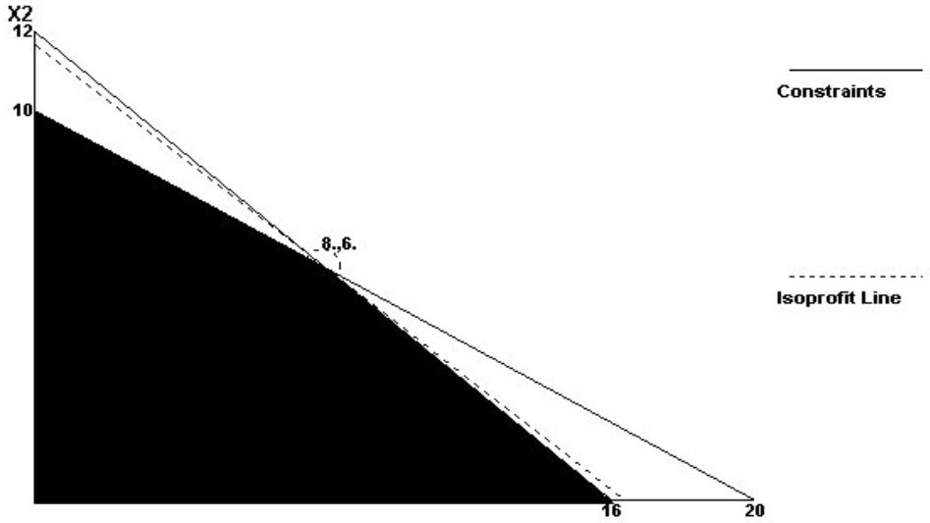
Answer:
Corner Points
X1 | X2 | Z
0 | 0 | 0
16 | 0 | 4,000.
0 | 10 | 3,500.
8 | 6 | 4,100.

Diff: 2
Topic: Graphical solution to a linear programming problem
Objective: LO-Module B-3
86) Phil Bert's Nuthouse is preparing a new product, a blend of mixed nuts. The product must be at most 50 percent peanuts, must have more almonds than cashews, and must be at least 10 percent pecans. The blend will be sold in one-pound bags. Phil's goal is to mix the nuts in such a manner that all conditions are satisfied and the cost per bag is minimized. Peanuts cost $1 per pound. Cashews cost $3 per pound. Almonds cost $5 per pound and pecans cost $6 per pound. Identify the decision variables of this problem. Write out the objective and the set of constraints for the problem. Do not solve.
Answer: Call the variables PN, AL, CA, and PC.
The objective function is to minimize $1PN + $3CA + $5AL + $6PC
subject to these four constraints:
PN + CA + AL + PC ≥ 1 (so that the bag weighs one pound)
.5PN - .5CA -.5AL - .5PC ≤ 0 (an inferior version reads PN ≤ .5)
-CA + AL ≥ 0
-.1PN - .1CA -.1AL +.9PC ≥ 0 (an inferior version reads PC ≥ .1)
Diff: 3
Topic: Formulating linear programming problems
AACSB: Analytic Skills
Objective: LO-Module B-1

87) A manager must decide on the mix of products to produce for the coming week. Product A requires three minutes per unit for molding, two minutes per unit for painting, and one minute for packing. Product B requires two minutes per unit for molding, four minutes for painting, and three minutes per unit for packing. There will be 600 minutes available for molding, 600 minutes for painting, and 420 minutes for packing. Both products have contributions of $1.50 per unit.
a. Algebraically state the objective and constraints of this problem.
b. Plot the constraints on the grid below and identify the feasible region.

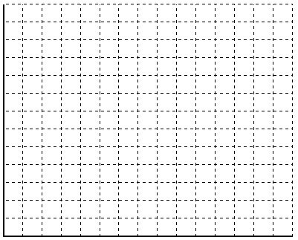
Answer: The objective of the problem is to maximize 1.50A + 1.50B, The constraints are 3A + 2B ≤ 600, 2A + 4B ≤ 600, and 1A + 3B ≤ 420. The plot and feasible region appear in the graph below.
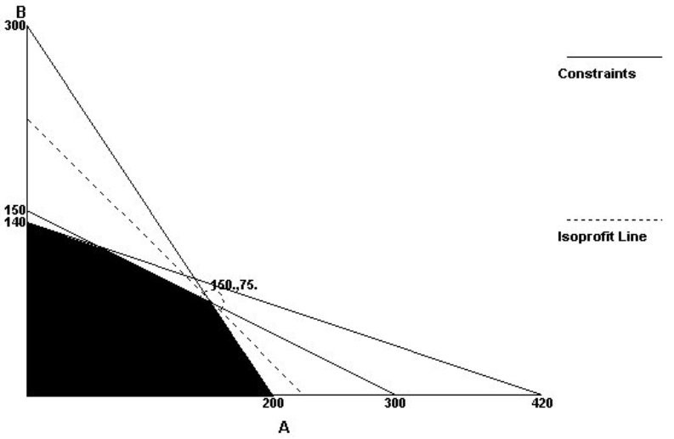
Diff: 1
Topic: Graphical solution to a linear programming problem
AACSB: Analytic Skills
Objective: LO-Module B-2
88) A craftsman builds two kinds of birdhouses, one for wrens (X1), and one for bluebirds (X2). Each wren birdhouse takes four hours of labor and four units of lumber. Each bluebird house requires two hours of labor and twelve units of lumber. The craftsman has available 60 hours of labor and 120 units of lumber. Wren houses profit $6 each and bluebird houses profit $15 each.

Use the software output that follows to interpret the problem solution. Include a statement of the solution quantities (how many of which product), a statement of the maximum profit achieved by your product mix, and a statement of "resources unused" and "shadow prices."

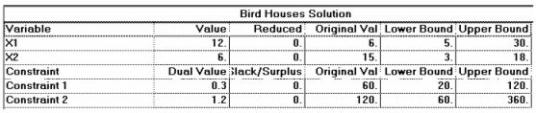
Answer: The optimal solution is X1 = 12, X2 = 6, which earns a profit of 12 * 6 + 6 * 15 = $162. Both labor and lumber are used up, so there are no resources unused. Additional labor is worth $0.30 per hour, and additional lumber is worth $1.20 per unit.
Diff: 2
Topic: Sensitivity analysis
AACSB: Analytic Skills
Objective: LO-Module B-4
89) The objective of a linear programming problem is to maximize 1.50A + 1.50B, subject to 3A + 2B ≤ 600, 2A + 4B ≤ 600, and 1A + 3B ≤ 420.
a. Plot the constraints on the grid below
c. Identify the feasible region and its corner points. Show your work.
d. What is the optimal product mix for this problem?

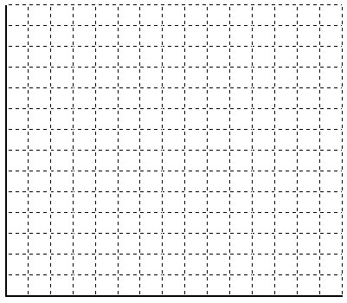
Answer: The objective of the problem is to maximize 1.50A + 1.50B,
The constraints are 3A + 2B ≤ 600, 2A + 4B ≤ 600, and 1A + 3B ≤ 420. The plot and feasible region appear in the graph below. The corner points are (0, 0), (200, 0), (0, 140), and (150, 75). The first three points can be read from the graph axes. The last corner point is the intersection of the equality 2A + 4B = 600 and 3A + 2B = 600. Multiply the first equality by ½ and subtract from the second, leaving 2A = 300 or A = 150. Substituting A = 150 in either equality yields B = 75, which is the optimal product mix for 337.50.

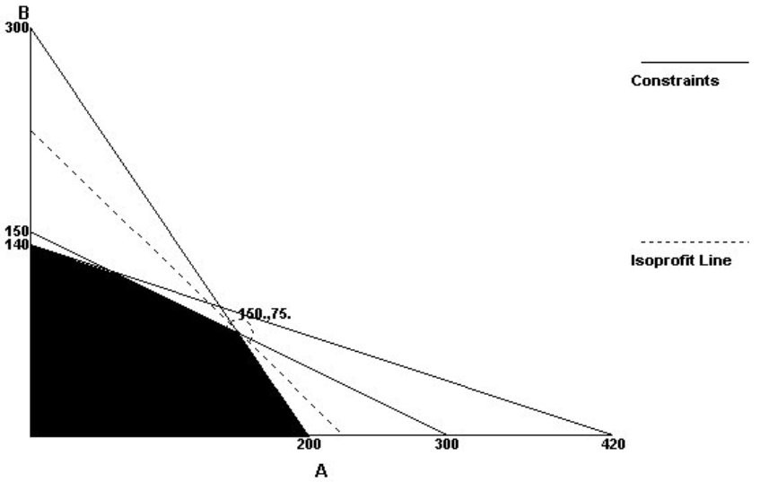
Diff: 2
Topic: Graphical solution to a linear programming problem
AACSB: Analytic Skills
Objective: LO-Module B-2

90) The property manager of a city government issues chairs, desks, and other office furniture to city buildings from a centralized distribution center. Like most government agencies, it operates to minimize its costs of operations. In this distribution center, there are two types of standard office chairs, Model A and Model B. Model A is considerably heavier than Model B, and costs $20 per chair to transport to any city building; each model B costs $14 to transport. The distribution center has on hand 400 chairs–200 each of A and B.

The requirements for shipments to each of the city's buildings are as follows:
Building 1 needs at least 100 of A
Building 2 needs at least 150 of B.
Building 3 needs at least 100 chairs, but they can be of either type, mixed.
Building 4 needs 40 chairs, but at least as many B as A.

Write out the objective function and the constraints for this problem. (Hint: there are eight variables–chairs for building 1 cannot be used to satisfy the demands for another building).
Answer: Let the variables be A1, A2, A3, and A4 for the type A chairs sent to each of the four buildings, and B1, B2, B3, and B4 for the type B chairs sent to each of the four buildings.

The objective function: minimize 20A1 + 20A2 + 20A3 + 20A4 + 14B1 + 14B2 + 14B3 + 14B4
Subject to these seven constraints:
A1 + A2 + A3 + A4 ≤ 200
B1 + B2 + B3 + B4 ≤ 200
A1 ≥ 100; B2 ≥ 150; A3 + B3 ≥ 100; A4 + B4 ≥ 40; and -A4 + B4 ≥ 0
Diff: 3
Topic: Formulating linear programming problems
AACSB: Analytic Skills
Objective: LO-Module B-1
91) The Queen City Nursery manufactures bags of potting soil from compost and topsoil. Each cubic foot of compost costs 12 cents and contains 4 pounds of sand, 3 pounds of clay, and 5 pounds of humus. Each cubic foot of topsoil costs 20 cents and contains 3 pounds of sand, 6 pounds of clay, and 12 pounds of humus. Each bag of potting soil must contain at least 12 pounds of sand, 12 pounds of clay, and 10 pounds of humus. Explain how this problem meets the conditions of a linear programming problem. Plot the constraints and identify the feasible region. Graphically or with corner points find the best combination of compost and topsoil that meets the stated conditions at the lowest cost per bag. Identify the lowest cost possible.
Answer: The problem formulation appears in the software panel below. The second panel contains the graphical and corner-point solutions. The minimum cost per bag is $0.45, and is achieved by using 2.4 cubic feet of compost and 0.8 cubic feet of topsoil.

Queen City Nursery
 | Compost | Topsoil |  | RHS
Minimize | 0.12 | 0.2
Sand | 4. | 3. | → | 12
Clay | 3. | 6. | → | 12
Humus | 5. | 12. | → | 10

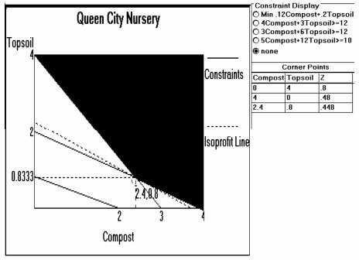
Diff: 2
Topic: Graphical solution to a linear programming problem
AACSB: Analytic Skills
Objective: LO-Module B-3
92) A stereo mail order center has 8,000 cubic feet available for storage of its private label loudspeakers. The ZAR-3 speakers cost $295 each and require 4 cubic feet of space; the ZAR-2ax speakers cost $110 each and require 3 cubic feet of space; and the ZAR-4 model costs $58 and requires 1 cubic foot of space. The demand for the ZAR-3 is at most 20 units per month. The wholesaler has $100,000 to spend on loudspeakers this month. Each ZAR-3 contributes $105, each ZAR-2ax contributes $50, and each ZAR-4 contributes $28. The objective is to maximize total contribution. Write out the objective and the constraints.
Answer: The objective is to maximize 105 ZAR-3 + 50 ZAR-2ax + 28 ZAR-4. There are constraints on storage space, budget, and maximum sales. The space constraint is 4 ZAR-3 + 3 ZAR-2ax + 1 ZAR-4 ≤ 8000. The budget constraint is 295 ZAR-3 + 110 ZAR-2ax + 58 ZAR-4 ≤ $100,000. The marketing constraint is 1 ZAR-3 ≤ 20.
Diff: 2
Topic: Formulating linear programming problems
AACSB: Analytic Skills
Objective: LO-Module B-1

93) Rienzi Farms grows sugar cane and soybeans on its 500 acres of land. An acre of soybeans brings a $1000 contribution to overhead and profit; an acre of sugar cane has a contribution of $2000. Because of a government program no more than 200 acres may be planted in soybeans. During the planting season 1200 hours of planting time will be available. Each acre of soybeans requires 2 hours, while each acre of sugar cane requires 5 hours. The company seeks maximum contribution (profit) from its planting decision.
a. Algebraically state the decision variables, objective and constraints.
b. Plot the constraints
c. Solve graphically, using the corner-point method.

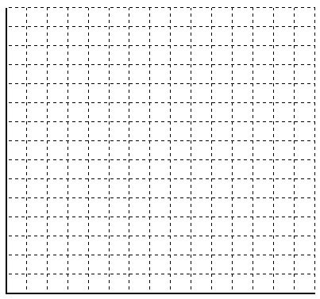
Answer: The problem statement is contained in the software panel below. The graphical and corner-point solutions are found in the second and third panels. The optimal solution is 200 acres in soybeans and 160 acres in sugar cane. There's not enough labor to plant all 500 acres when 200 acres are in soybeans.

Rienzi Farms Solution
 | X1 | X2 |  | RHS | Dual
Maximize | 1,000. | 2,000.
Acres | 1. | 1. | ⇐ | 500. | 0.
Soybean restriction | 1. | 0. | ⇐ | 200. | 200.
Planting labor | 2. | 5. | ⇐ | 1,200. | 400.
Solution ---> | 200. | 160. |  | 520,000.

Corner Points
X1 | X2 | Z
0 | 0 | 0.
200 | 0 | 200,000.
0 | 240 | 480,000.
200 | 160 | 520,000.

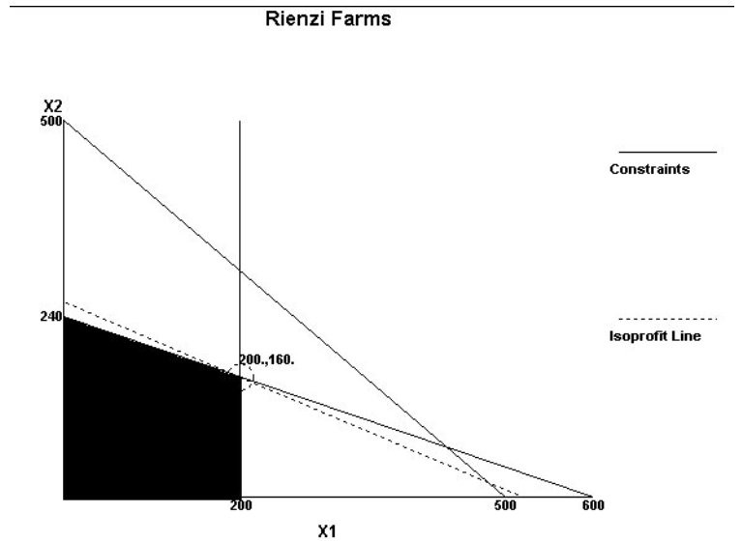
Diff: 2
Topic: Graphical solution to a linear programming problem
AACSB: Analytic Skills
Objective: LO-Module B-2

94) South Coast Papers wants to mix two lubricating oils (A and B) for its machines in order to minimize cost. It needs no less than 3,000 gallons in order to run its machines during the next month. It has a maximum oil storage capacity of 4,000 gallons. There are 2,000 gallons of Oil A and 4,000 of Oil B available. The mixed fuel must have a viscosity rating of no less than 40.

When mixing fuels, the amount of oil obtained is exactly equal to the sum of the amounts put in. The viscosity rating is the weighted average of the individual viscosities, weighted in proportion to their volumes. The following is known: Oil A has a viscosity of 45 and costs 60 cents per gallon; Oil B has a viscosity of 37.5 and costs 40 cents per gallon.

State the objective and the constraints of this problem. Plot all constraints and highlight the feasible region. Use your (by now, well-developed) intuition to suggest a feasible (but not necessarily optimal) solution. Be certain to show that your solution meets all constraints.
Answer: The problem formulation appears below. The only unusual constraint is the fifth one. This begins as the viscosity expression: viscosity = (45A + 37.5B) / (A + B) = 40, which becomes 5A = 2.5B. It is not possible to meet the restrictions with only Oil A or only Oil B. Most students will discover that a combination is required. They need to show that their mix has a high enough viscosity by substituting their quantities into the viscosity inequality (as well as showing that their quantities are within the four volume constraints).

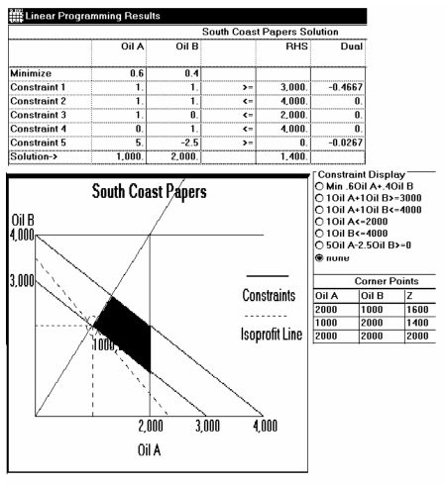
Diff: 3
Topic: Graphical solution to a linear programming problem
AACSB: Analytic Skills
Objective: LO-Module B-3
95) Lost Maples Winery makes three varieties of contemporary Texas Hill Country wines: Austin Formation (a fine red), Ste. Genevieve (a table white), and Los Alamos (a hearty pink Zinfandel). The raw materials, labor, and contribution per case of each of these wines is summarized below.

 | Grapes Variety A bushels | Grapes Variety B bushels | Sugar pounds | Labor (man-hours) | Contrib. per case
Austin Formation | 4 | 0 | 1 | 3 | $24
Ste. Genevieve | 0 | 4 | 0 | 1 | $28
Los Alamos | 2 | 2 | 2 | 2 | $20

The winery has 2800 bushels of Variety A grapes, 2040 bushels of Variety B grapes, 800 pounds of sugar, and 1060 man-hours of labor available during the next week. The firm operates to achieve maximum contribution. Refer to the POM for Windows panels showing the solution to this problem.

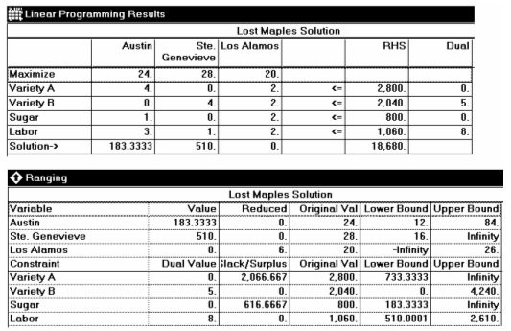

Answer the following questions.
a. For maximum contribution, how much of each wine should be produced?
b. How much contribution will be made by selling the output?
c. Is there any sugar left over? If so, how much? If not, what is its shadow price (dual value)? Explain what this value means to Lost Maples' management.
d. Interpret the meaning of the lower bound to Labor in the Ranging analysis. That is, explain how the solution would change if the amount of labor fell below that lower value.
e. Interpret the meaning of the upper bound to Los Alamos wine in the Ranging analysis.
Answer: (a) 183 1/3 cases of Austin Formation, 510 cases of Ste. Genevieve; (b) maximum contribution is $18,680; (c) There are 617 pounds of sugar remaining; its dual value is zero, indication that management should not seek out any more sugar; (d) if the amount of labor fell below the 510 hour level, its dual value would rise; (e) Los Alamos is not currently included in the solution; it would enter the solution only if its contribution rose over the ranging limit of $26 per case.
Diff: 2
Topic: Sensitivity analysis
AACSB: Analytic Skills
Objective: LO-Module B-4

96) Suppose that a chemical manufacturer is deciding how to mix two chemicals, A and B. A costs $5/gram and B costs $4/gram if they are ordered above the current supply level. There are currently 40 grams of A and 30 grams of B that must be used in the mix or they will expire. If a customer wants 1 kg of the mix with at least 40% A but no more than 55% A, how many grams of each chemical should be included in the mix?
Answer: Students should start by using all of the A and B supplies on hand. This totals 70grams and means that 930 grams will need to be ordered. A must have between 400 and 550 grams while B will be 1000-A grams. Removing the already assigned supplies gives that
A (ordered) between 360 and 510
B(ordered) = 930-A => A+B=930
Students should then recognize that the corner points lie where A=360 (ordered), B=570 (ordered) and A = 510 (ordered) and B = 420 (ordered). Using the corner-point approach, the total cost will be minimized at one of these two locations.
TC(A=360 ordered) = 360*5+570*4 = $4080
TC(A=510 ordered) = 510*5+420*4 = $4230
Thus the manufacturer should order 360 grams of A and 570 grams of B. Mixing these ordered supplies with the on hand inventory (treated as being free since it will expire) would give a mix of 400 grams of A and 600 grams of B.
Diff: 2
Topic: Solving minimization problems
AACSB: Analytic Skills
Objective: LO-Module B-5

97) Suppose that a constraint for assembly time has a shadow price of $50/hour for 15 hours in either direction and that all available assembly time is currently used (would require overtime to do more). If the salary of workers is $30 and they receive 50% extra pay for overtime what should management do?
Answer: Reducing assembly time would save $30/hour but would cost $50/hour in lost profits.
Doing nothing would not change profits.
Increasing assembly time would cost an extra $45 per hour but increase profits by $50/hour. Thus management should be willing to pay for 15 hours of overtime and perhaps should look into increasing base assembly time capacity in the future.
Diff: 2
Topic: Sensitivity analysis
AACSB: Analytic Skills
Objective: LO-Module B-4
98) Suppose an LP problem was subject to constraints of
2X+Y> 10
X+3Y> 20
Suppose that a new constraint is added, of the form 3X+A*Y> 90. What is the largest value that A can have so that this new constraint is redundant?
Answer: Students should recognize that both this new constraint and constraint two intersect the X-axis where X=20. Thus to be redundant the new constraint must simply intersect the y-axis at the same point as the old one, or where Y=20/3.
Setting 90/A=20/3 gives A=13.5
Diff: 2
Topic: Graphical solution to a linear programming problem
AACSB: Analytic Skills
Objective: LO-Module B-2

99) A feedlot is trying to decide on the lowest cost mix that will still provide adequate nutrition for its cattle. Suppose that the numbers in the chart represent the number of grams of ingredient per 100 grams of feed and that the cost of Feed X is $5/100grams, Feed Y is $3/100grams, and Feed X is $8/100 grams. Each cow will need 50 grams of A per day, 20 grams of B, 30 grams of C, and 10 grams of D. If the feedlot can get no more than 200 grams per day per cow of any of the feed types determine the constraints governing the problem.

Ingredient | X | Y | Z
A | 10 | 15 | 5
B | 30 | 10 | 20
C | 40 | 0 | 20
D | 0 | 20 | 30

Answer: Objective: Minimize cost = 5X+3Y+8Z where X,Y,Z are in grams and cost is in cents
Subject to:
A requirement: .1X+.15Y+.05Z ≥ 50
B requirement: .3X + .1Y + .2Z ≥ 20
C requirement: .4X + .2Z ≥ 30
D requirement: .2Y+.3Z ≥10
Purchase limit: X≤200
Purchase limit: Y≤200
Purchase limit: Z≤200
Where X,Y, and Z are in grams
Diff: 2
Topic: Linear programming applications
AACSB: Analytic Skills
Objective: LO-Module B-6
100) Suppose that a constraint is given by X+Y≤10. If another constraint is given to be 3X+2Y≥15 determine the corners of the feasible solution. If the profit from X is 5 and the profit from Y is 10, determine the maximum profit.
Answer: Corners are (10,0), (5,0), (0,7.5), and (0,10). Maximum profit is at the corner (0,10), which yields $100 of profit.
Diff: 2
Topic: Graphical solution to a linear programming problem
AACSB: Analytic Skills
Objective: LO-Module B-3

